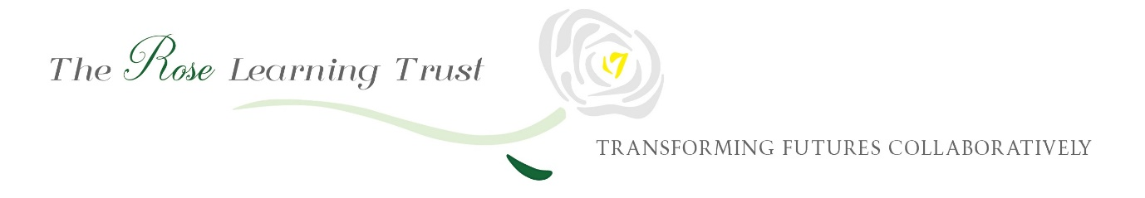

Local Governing Body
Agenda Autumn Term 2019
26th November 2019
8am to 10am

1 ELECTION OF CHAIR AND VICE CHAIR
1.1 Election of the Chair - even if one single nomination is received a confirming vote should be taken
1.2 Election of the Vice Chair - even if one single nomination is received a confirming vote should be taken

2 APOLOGIES FOR ABSENCE
2.1 To accept, apologies for absence
2.2 To receive, but not accept, apologies for absence

3 DECLARATION OF INTERESTS
3.1 Individual board members to declare any personal, business or other governance interests on any item on the agenda

4 ITEMS OF URGENT BUSINESS
4.1 Chair to determine any items of urgent business to be considered under item 8 below.
i) Resignation of Nicky Fallon as Staff Governor from 13.11.19 – Chairs Action
ii) Appointment of Jayne Miller as Staff Governor from 13.11.19 – Chairs Action
iii) Appointment of Nicky Fallon as Associate Governors from 13.11.19 – Chairs Action
iv) Approval of Adoption Leave appointment – more info in item 6.1 – Chairs Action
v) Approval of LSA appointment from 18.11.19 – more info in item 6.1 – Chairs Action
vi) Signing of KCSIE – see agenda item 8
vii) School Closure on 15th November 2019 – more info in item 6.4e – Chairs Action

5 LOCAL GOVERNING BOARD MINUTES
5.1 Approval of the Minutes
To agree the minutes of the meeting held on 18th June 2019 – see minutes
5.2 Matters Arising from the Minutes
To consider any matters arising from the minutes, not already covered on the agenda

Staff who are delivering papers to the LGB are invited from this point of the meeting
i) Nicky Fallon, Associate Governor to join meeting

6 EXECUTIVE LEADER’S TERMLY WRITTEN REPORT

6.1 Strategic Leadership – see paper
a) Understanding the Trust Board’s Vision and Strategic Plan – see paper
b) Overview of Academy Self-Evaluation – see paper
c) Approval of the Academy Improvement Plan 2019/2020 - see paper
6.2 Accountability for Educational Standards
a) Impact of Pupil Premium Funding, annual report and strategy – see paper
b) Impact of PE and Sport Premium Funding annual report and strategy – see paper
c) Annual report from the designated teacher for looked after and previously looked after children and SEN children – see paper
d) Staffing matters update – forms part of Heads Report – see paper 6.1 and staffing structure
e) Reports from governors undertaking designated governance roles – see paper
f) Data Dashboard Term 3 - Verbal update
g) 2018-2019 Educational Outcomes – see paper

6.3 Accountability for Financial Performance
a) Review of the Register of Interests – see paper
b) October budget monitoring – see paper
c) Changes to the Academies Financial Handbook 2019 – see paper
d) Woodfield Financial Procedures 2019-20 – for approval – see paper
e) External Audit Internal Assurance Report 2018/19 – see paper

6.4 Compliance with Statutory and Other Contractual Requirements
a) Safeguarding report – see paper
b) New Ofsted Framework – circulated to all governors and significance of changes discussed (curriculum focussed) – see paper
c) Updating the GIAS portal – verbal
https://get-information-schools.service.gov.uk/Establishments/Establishment/Details/143451
d) Updating governance information on the website – verbal –
https://woodfieldprimaryschool.co.uk/information/governors/
e) Receive additional reports from Business Manager: to include H&S, Risk Register, finance update, HR – see paper
f) IT Data Security/GDPR audit feedback to include any SAR/data breaches/FOI - see paper

7 GOVERNANCE REVIEW
7.1 Structures

Understanding the written Scheme of Delegation, including where appropriate: -
a) Agreeing the membership of specific panels – see paper
b) Agreeing individual governors undertaking designated governance roles – see paper
c) Updating contacts directory for all LGB – see paper

7.2 People
a) Review of the LGB membership – see paper
b) Understanding the Trust’s Code of Conduct for Effective Governance – see paper
c) Reviewing governance training and development needs for the academic year – see paper

8. ANY OTHER URGENT BUSINESS

8.1 To consider any other urgent business agreed by the chair at item 4
a) KCISE Update to be circulated with a signature obtained to confirm all LGB have read and understood the full document.

9. CONFIDENTIALITY
9.1 To consider the confidentiality of any items discussed during the meeting

10. DATES OF FUTURE MEETINGS
10.1 To note the dates of future Local Governing Board meetings for 2019/2020:

Full LGB MEETINGS
Term 1
26th November 2019 – 8am

Term 2
2nd March 2020 – 8am

Term 3
23rd June 2020 – 8am

Committees – Finance
Term 2
28th April 2020 – 8am

Term 3
7th July 2020 – 8am (Approval 2021 initial budget)

11. CLOSE OF MEETING
11.1 Chair to close the meeting

15 minute comfort break

Training for Governors
10.15am to 10.45am

Focus of the training: Governor Hub

Trainer: Jayne Miller, School Business Manager

10.45am to 11.15am

Focus of the training: Vocabulary Development

Trainer: David Longley, Governor

